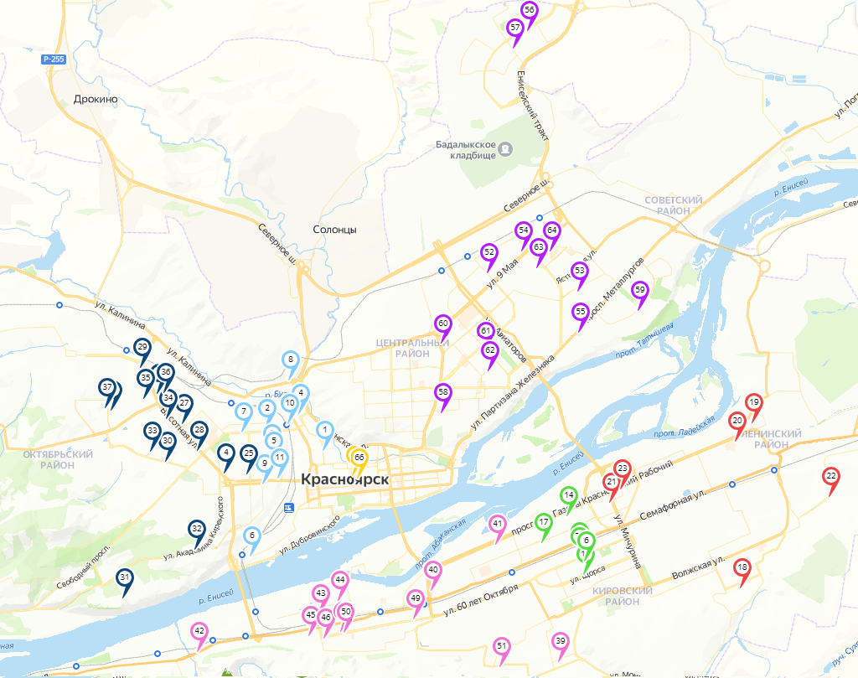

https://yandex.ru/maps/62/krasnoyarsk/?ll=92.921216%2C56.036128&mode=usermaps&source=constructorLink&um=constructor%3A2f89ccc4967feedc74954aa179a4d203ae02ee4f341a214d3b695a2716b15e58&z=12

